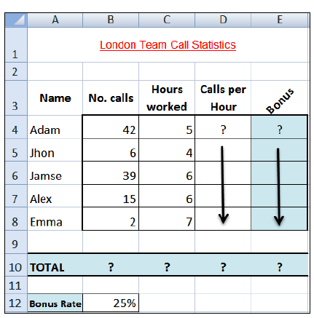

**Ques. – 2**

1. **Open a new workbook and save the file with the name “Call Statistics”.**
2. **Delete Sheet 2 & 3, and rename Sheet 1 to (Call Statistics).**
3. **Enter the labels and values in the exact cells locations as desired.**
4. **Set the row height of rows 1 & 3 to size 30; and rows 4 until 10 to size 20.**
5. **Set labels alignment appropriately.**
6. **Use Warp Text, Orientation and merge cells as desired.**
7. **Apply border, gridlines and shading to the table as desired.**
8. **Format column E to include euro (€) sign with two decimal places.**
9. **Format cell B12 to include % sign with 0 Decimal places.**
10. **Calculate the Calls per Hour, enter a formula in cell D4 to divide numbers of calls by Hours worked. Using AutoFill, copy the formula to the remaining cells.**
11. **Calculate the Bonus. Enter a formula in cell E4 to multiply ‘Calls per Hours’ by the fixed Bonus Rate in cell B12. Using AutoFill, copy the formula to the remaining cells.**
12. **Calculate the ‘TOTAL’.**
13. **Set the worksheet vertically and horizontally on the page.**
14. **Create a header that includes your name in the left section, and your ID number in the right section.**
15. **Create the footer that includes the current Date in the center.**